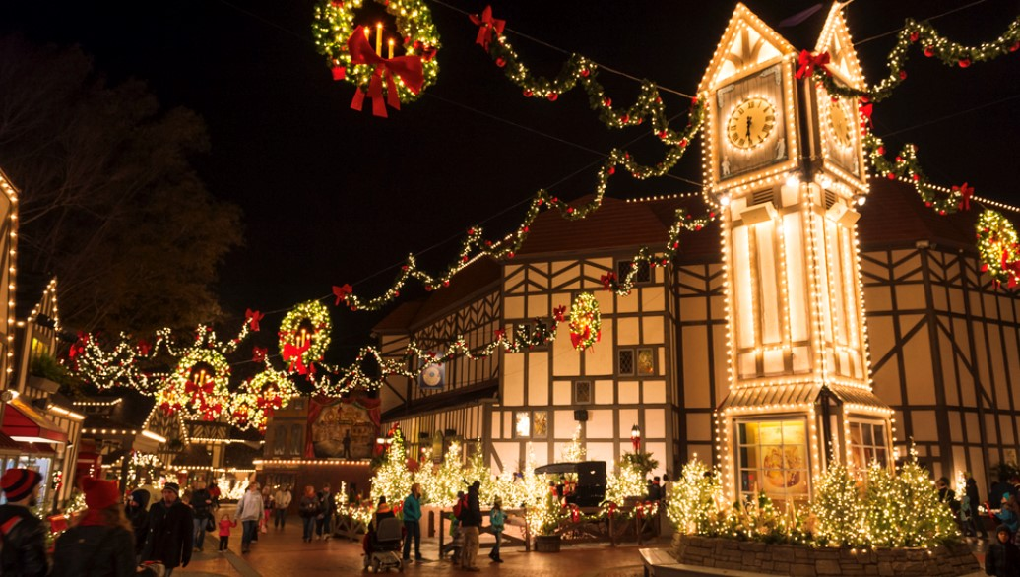

**Christmas in the South is all about tradition, family, food, friends and fun. You will feel like family as you are enlightened about early Christmas decoration in colonial Williamsburg, dine in a tavern, be dazzled by the millions of brilliant lights in Richmond’s botanical garden, visit a James River plantation, dine at a Virginia winery and enjoy evening of theater. This tour will allow you to explore America’s most historic state capitol and stand where America began at Jamestown and course; shop, shop & shop!**

**Some Highlights**

* **Garden of Lights**
* **Shirley Plantation Yule Tide Tour**
* **Decorations Tour in Williamsburg**
* **Yankee Candle Snow Village**
* **Grand Illumination**
* **Gingerbread Demonstration**
* **Busch Gardens Christmas Town**
* **Shopping Merchant Square**
* **Colonial Williamsburg Exhibits**
* **Eight Meals**
* **Williamsburg Lodge for Three Nights**

**Amazing Travel Treasures**

**Amazingtraveltreasures.com**

**Can customize this tour exclusively for your group!**

**For more information contact:**

**Mark Warther**

**mark@amazingtraveltreasures.com**

**330-556-4535**

**Dawn Dornes**

**dawn@amazingtraveltreasures.com**

**717-333-9628**

**A Colonial Williamsburg Christmas**