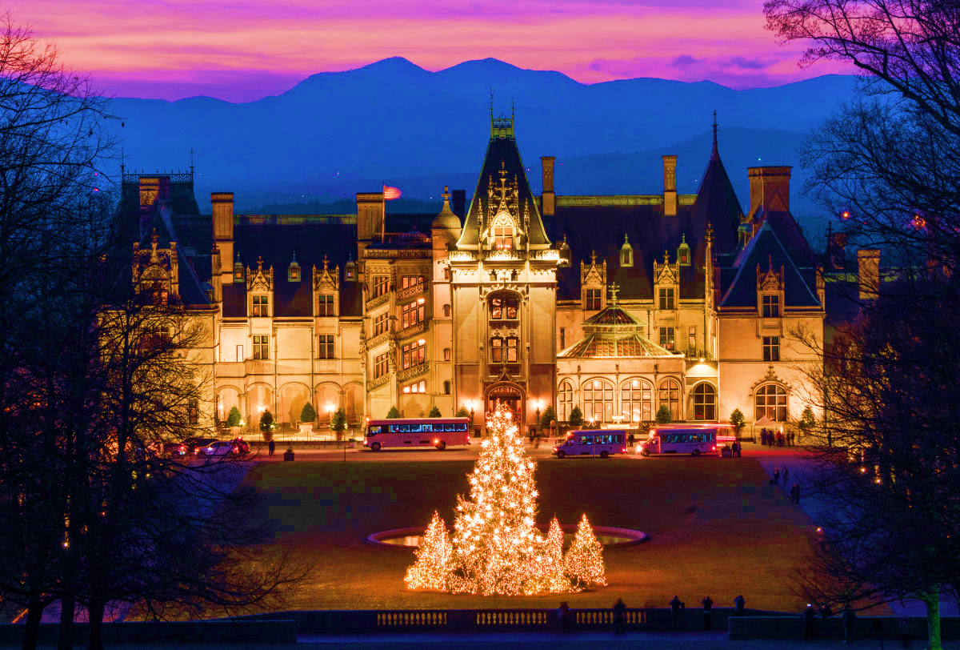

**Amazing Travel Treasures**

**Amazingtraveltreasures.com**

**Can customize this tour exclusively for your group!**

**For more information contact:**

**Mark Warther**

**mark@amazingtraveltreasures.com**

**330-556-4535**

**Dawn Dornes**

**dawn@amazingtraveltreasures.com**

**717-333-9628**

**The Biltmore House and Estate’s annual Christmas decorations are certainly one of the wonders of the holiday season in Asheville, North Carolina. The estate is the site of the largest privately-owned house in the United States.  Everywhere you look, the holiday decorations adorn each area of the estate.  Our home for the next 4 nights is the Village Hotel on Biltmore Estate which is a short stroll from the shops, restaurants, and Winery of Antler Hill Village, all beautified and bedecked with festive Christmas displays.**

**Highlights:**

* **Four Nights At The Biltmore Village Hotel**
* **Biltmore Mansion & Estate Daytime tour**
* **Candlelight Tour of Biltmore Mansion**
* **Blue Ridge Parkway Tour**
* **Blue Ridge Mountain Opry Dinner & Show**
* **Black Mountain**
* **Seven Meals**

***Christmas at the Biltmore!***